**5/4/22**

**5/8**

[**https://docs.pytest.org/en/latest/how-to/writing_plugins.html#writing-plugins**](https://docs.pytest.org/en/latest/how-to/writing_plugins.html#writing-plugins)

**Compare two json files or payload files to be same or not**

[**https://wonzwang.blog.csdn.net/article/details/108410156?spm=1001.2101.3001.6650.3&utm_medium=distribute.pc_relevant.none-task-blog-2%7Edefault%7ECTRLIST%7ERate-3.topblog&depth_1-utm_source=distribute.pc_relevant.none-task-blog-2%7Edefault%7ECTRLIST%7ERate-3.topblog&utm_relevant_index=6**](https://wonzwang.blog.csdn.net/article/details/108410156?spm=1001.2101.3001.6650.3&utm_medium=distribute.pc_relevant.none-task-blog-2%7Edefault%7ECTRLIST%7ERate-3.topblog&depth_1-utm_source=distribute.pc_relevant.none-task-blog-2%7Edefault%7ECTRLIST%7ERate-3.topblog&utm_relevant_index=6)

**pytest_collection_modifyitems**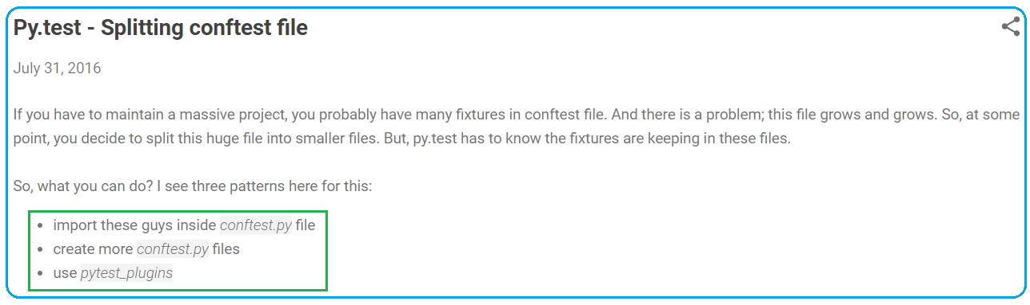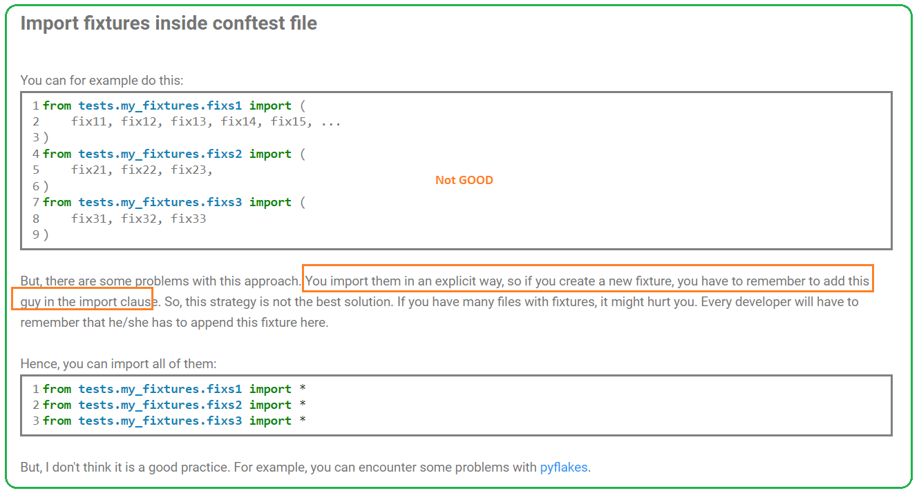 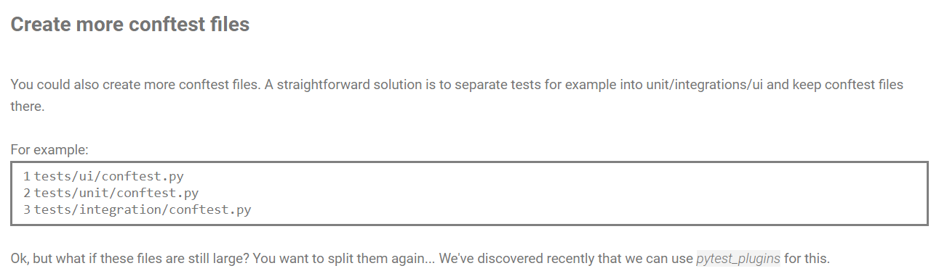 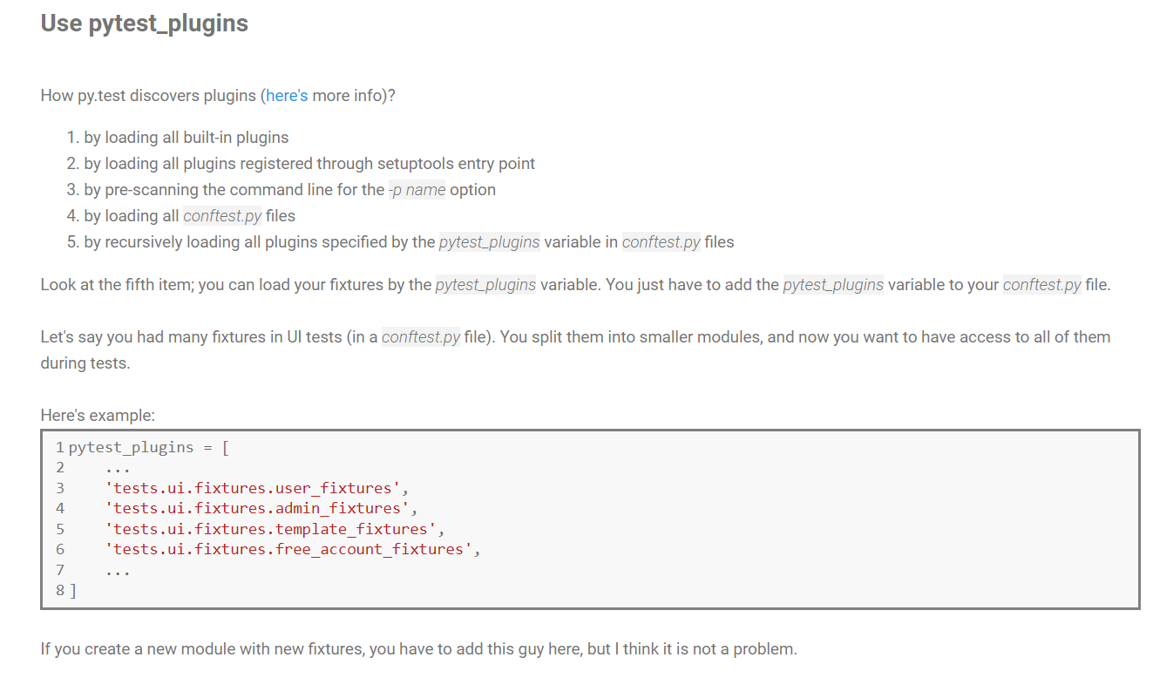 https://dock2learn.com/tech/fixtures-in-pytest-all-you-need-to-know/ 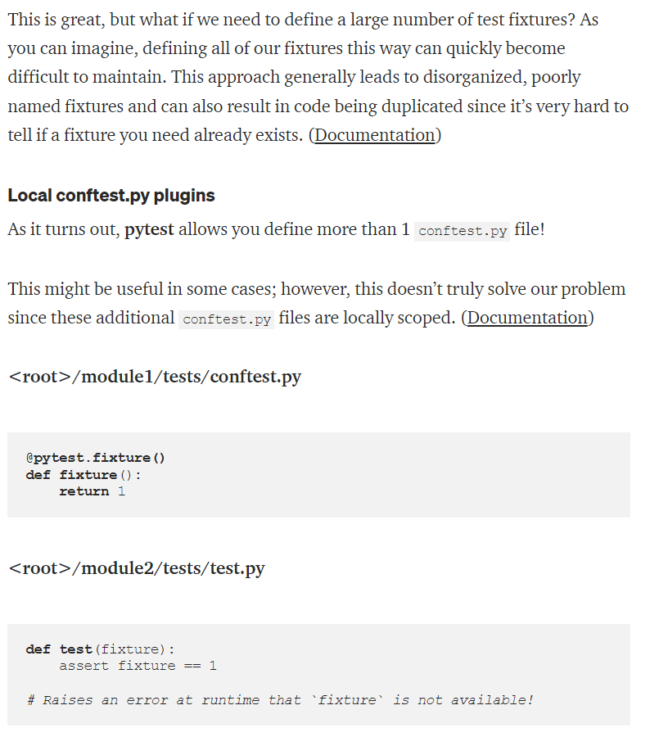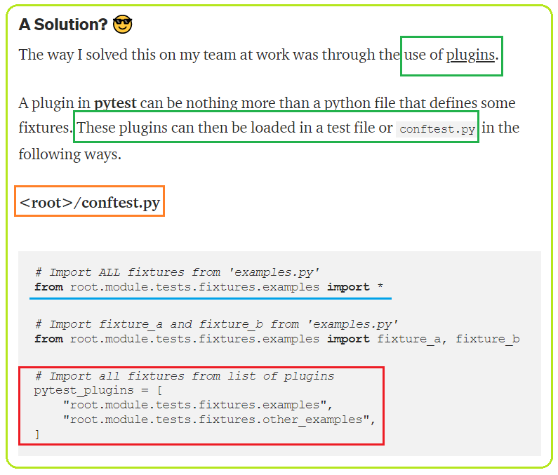 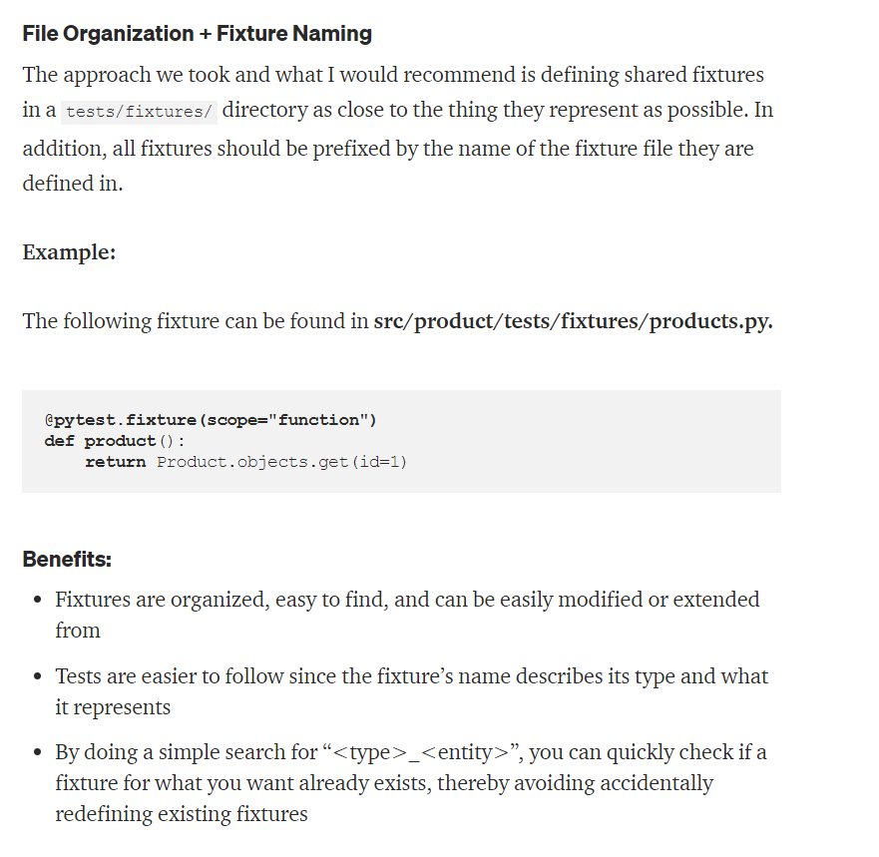 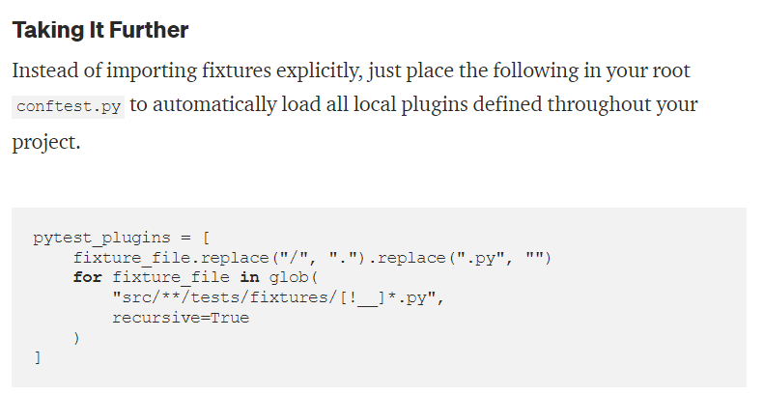

**Data driven**

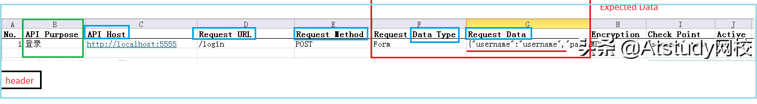

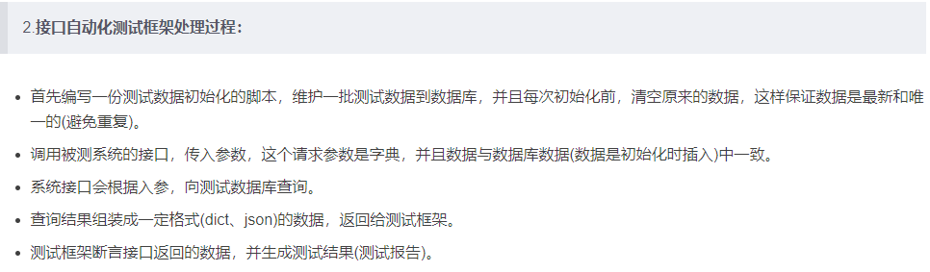 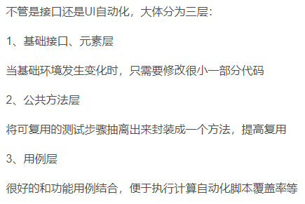

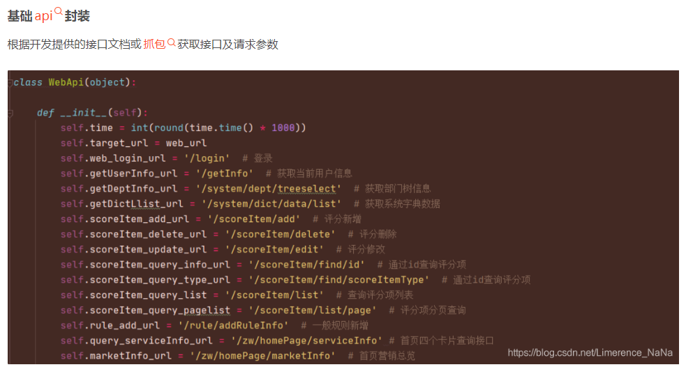 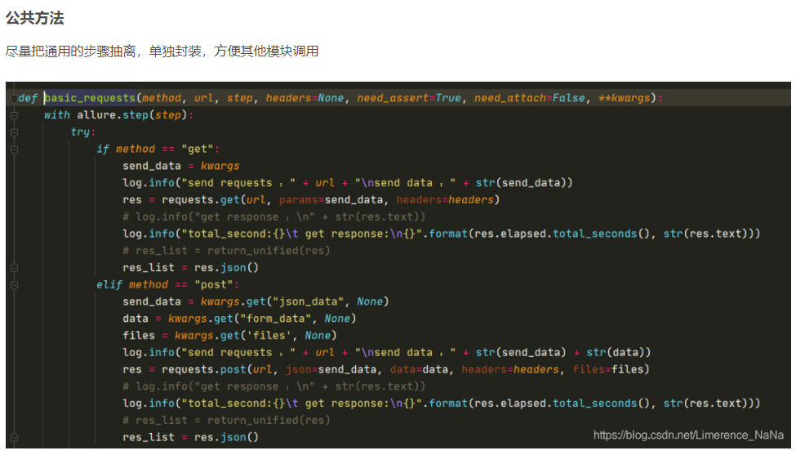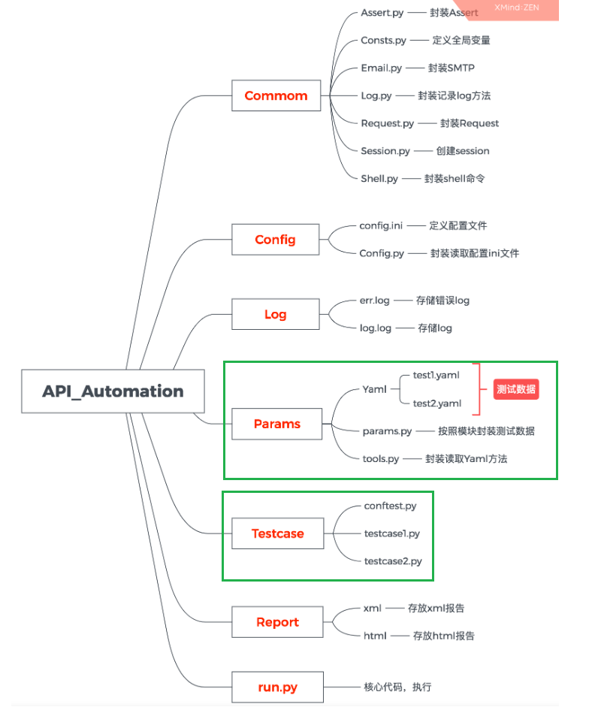 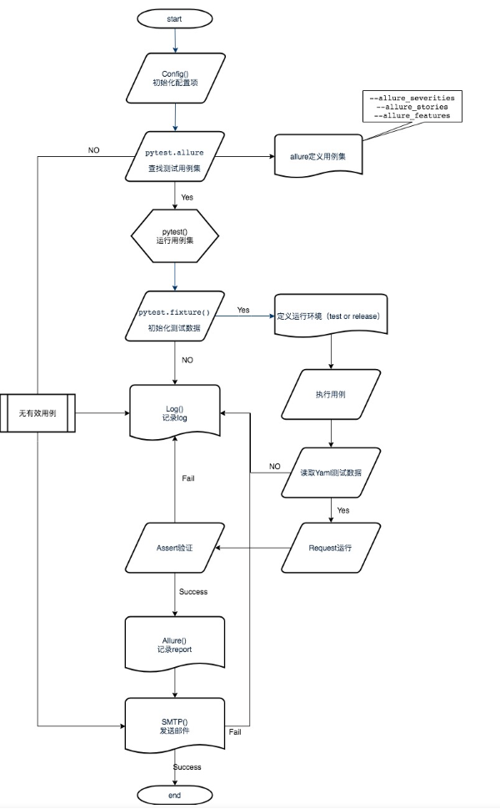 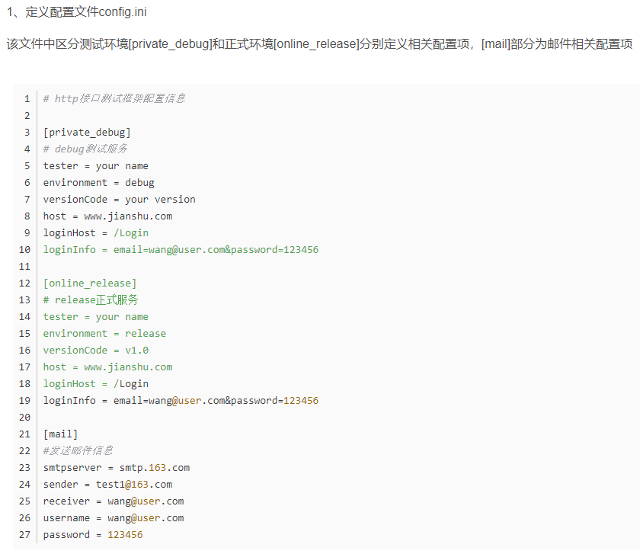 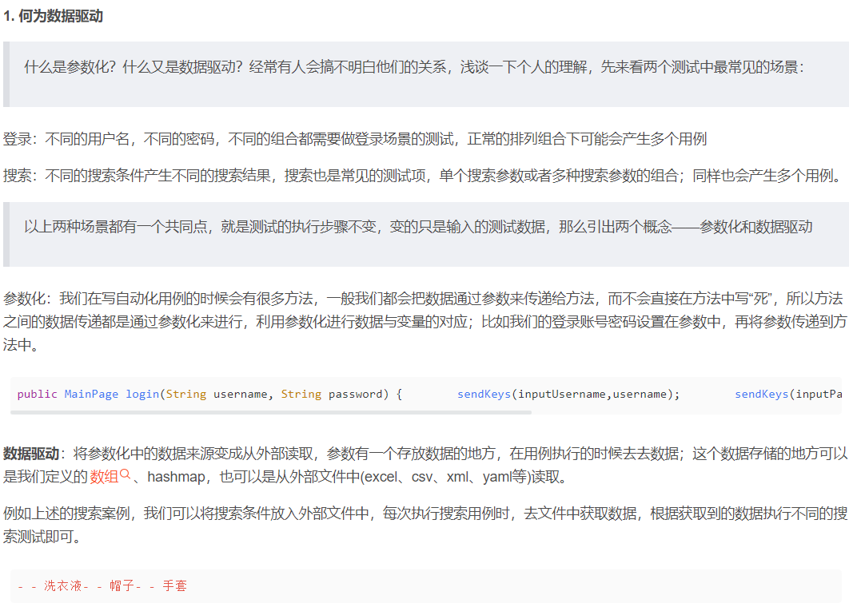 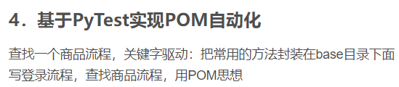 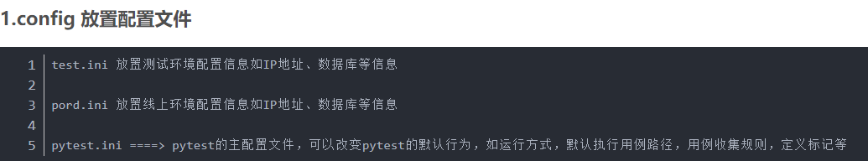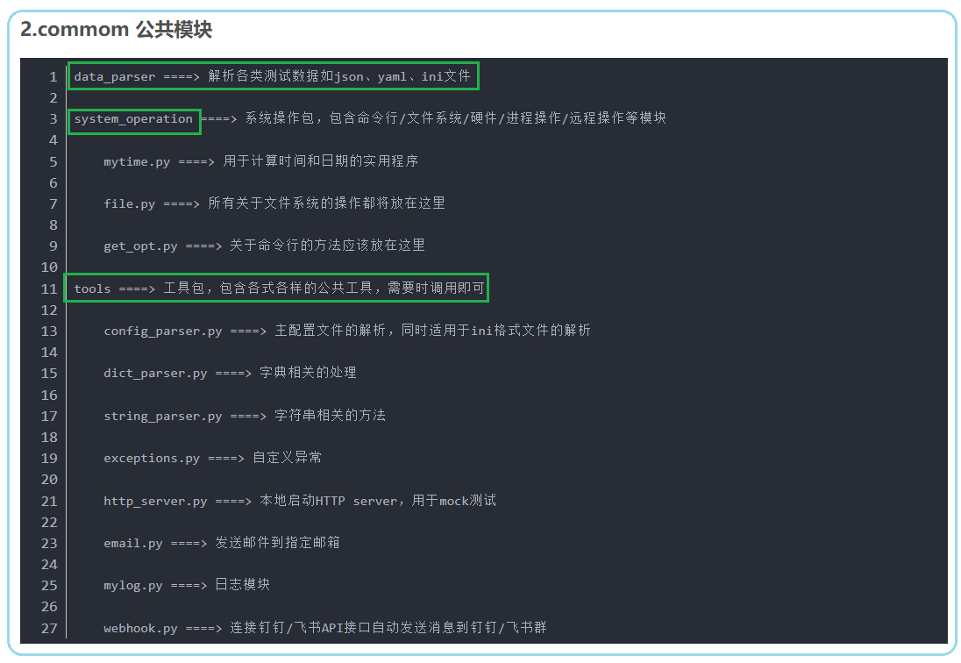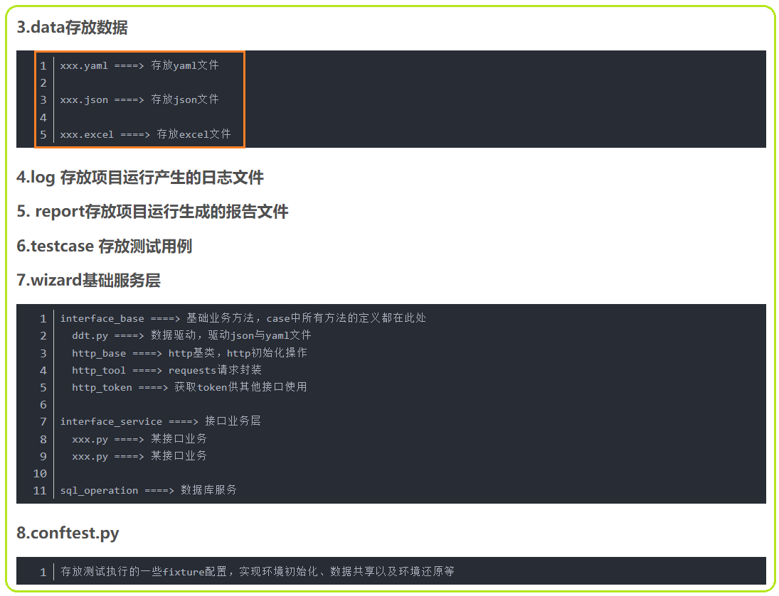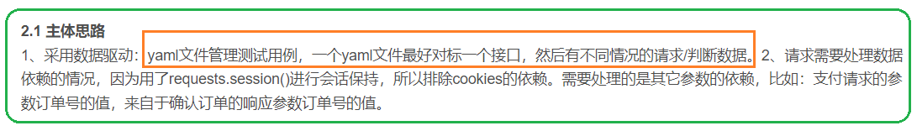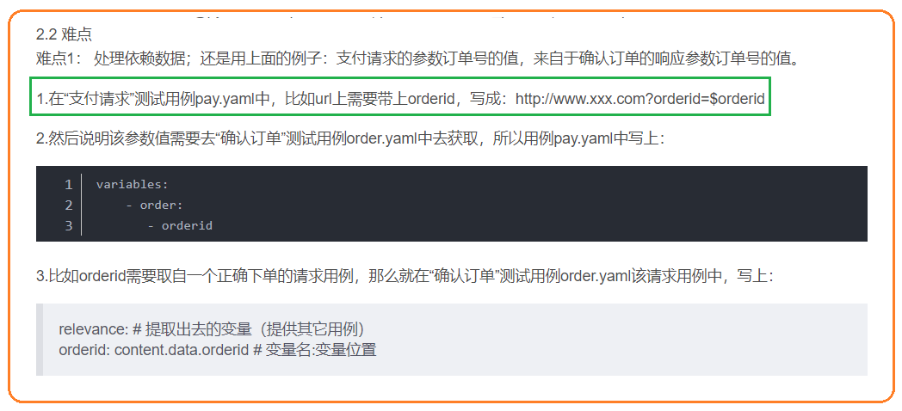 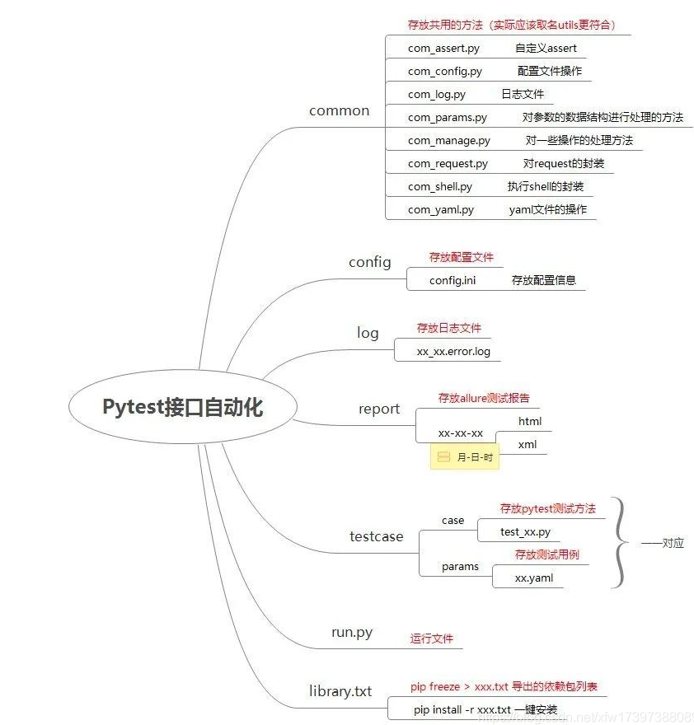 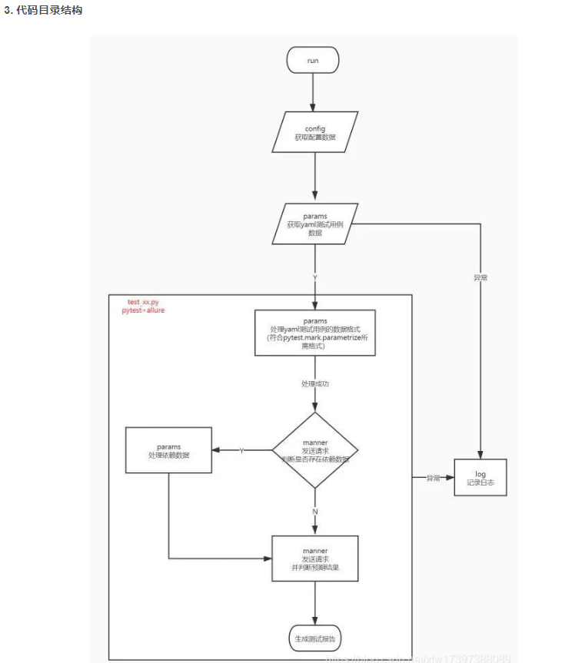

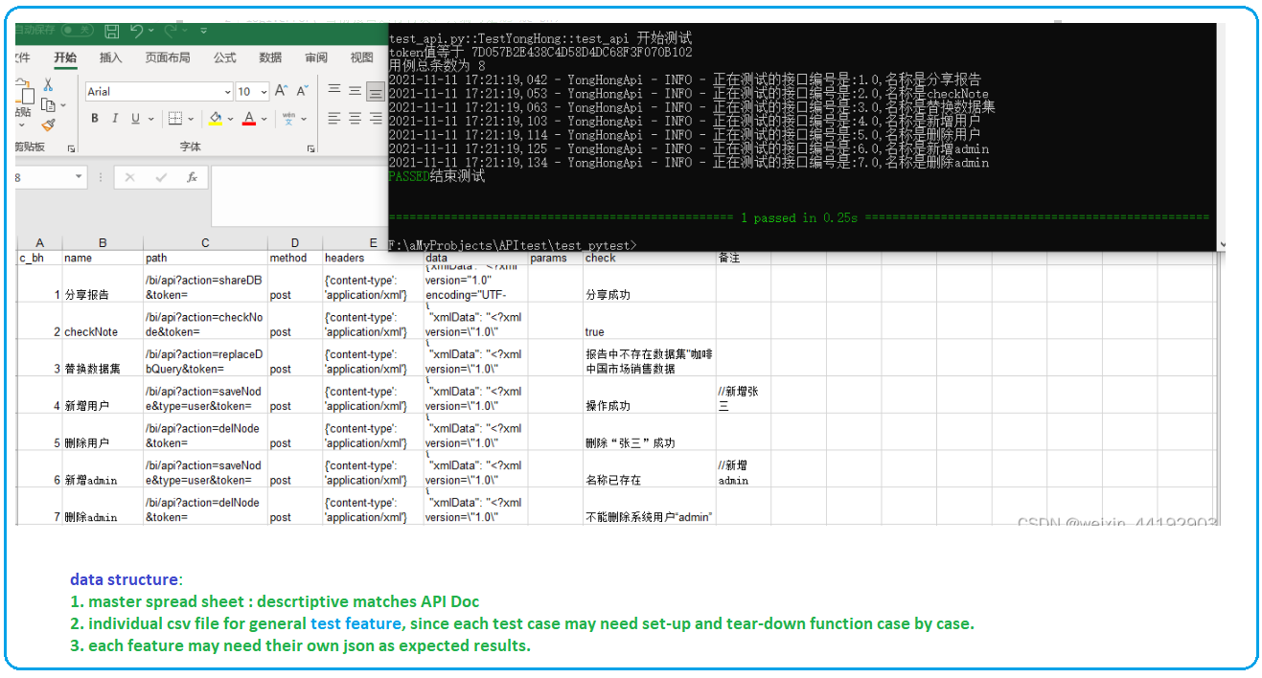

# Pytest+Yaml+Excel 接口自动化测试框架

[**https://blog.csdn.net/u010454117/article/details/122443722?ops_request_misc=%257B%2522request%255Fid%2522%253A%2522165153499016782184647987%2522%252C%2522scm%2522%253A%252220140713.130102334.pc%255Fall.%2522%257D&request_id=165153499016782184647987&biz_id=0&utm_medium=distribute.pc_search_result.none-task-blog-2~all~first_rank_ecpm_v1~rank_v31_ecpm-21-122443722.142^v9^pc_search_result_control_group,157^v4^control&utm_term=pytest%2Brequests+%E6%95%B0%E6%8D%AE%E9%A9%B1%E5%8A%A8&spm=1018.2226.3001.4187**](https://blog.csdn.net/u010454117/article/details/122443722?ops_request_misc=%257B%2522request%255Fid%2522%253A%2522165153499016782184647987%2522%252C%2522scm%2522%253A%252220140713.130102334.pc%255Fall.%2522%257D&request_id=165153499016782184647987&biz_id=0&utm_medium=distribute.pc_search_result.none-task-blog-2~all~first_rank_ecpm_v1~rank_v31_ecpm-21-122443722.142%5ev9%5epc_search_result_control_group,157%5ev4%5econtrol&utm_term=pytest%2Brequests+%E6%95%B0%E6%8D%AE%E9%A9%B1%E5%8A%A8&spm=1018.2226.3001.4187)

1. **Pytest+requests+yaml+Allure+Jenkins+docker**

[**https://blog.csdn.net/csdnchengxi/article/details/124202847?ops_request_misc=%257B%2522request%255Fid%2522%253A%2522165153499016782184647987%2522%252C%2522scm%2522%253A%252220140713.130102334.pc%255Fall.%2522%257D&request_id=165153499016782184647987&biz_id=0&utm_medium=distribute.pc_search_result.none-task-blog-2~all~first_rank_ecpm_v1~rank_v31_ecpm-6-124202847.142^v9^pc_search_result_control_group,157^v4^control&utm_term=pytest%2Brequests+%E6%95%B0%E6%8D%AE%E9%A9%B1%E5%8A%A8&spm=1018.2226.3001.4187**](https://blog.csdn.net/csdnchengxi/article/details/124202847?ops_request_misc=%257B%2522request%255Fid%2522%253A%2522165153499016782184647987%2522%252C%2522scm%2522%253A%252220140713.130102334.pc%255Fall.%2522%257D&request_id=165153499016782184647987&biz_id=0&utm_medium=distribute.pc_search_result.none-task-blog-2~all~first_rank_ecpm_v1~rank_v31_ecpm-6-124202847.142%5ev9%5epc_search_result_control_group,157%5ev4%5econtrol&utm_term=pytest%2Brequests+%E6%95%B0%E6%8D%AE%E9%A9%B1%E5%8A%A8&spm=1018.2226.3001.4187)

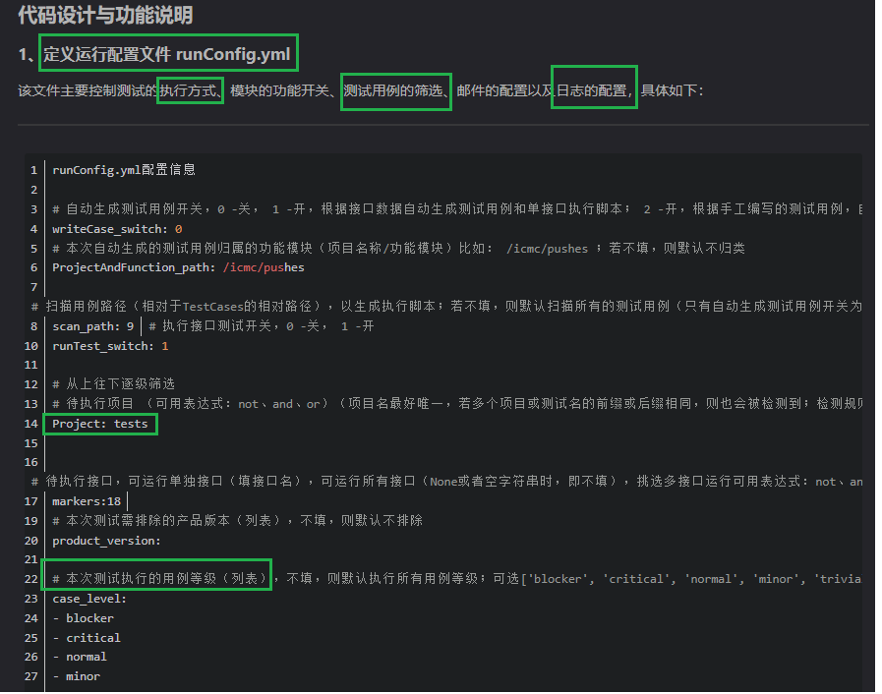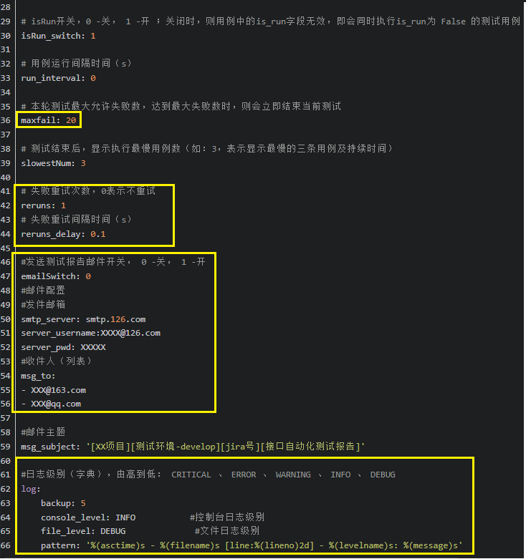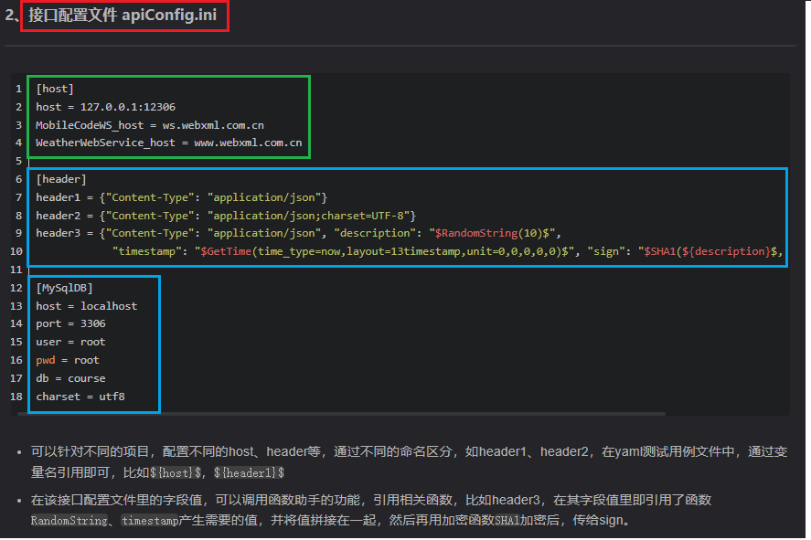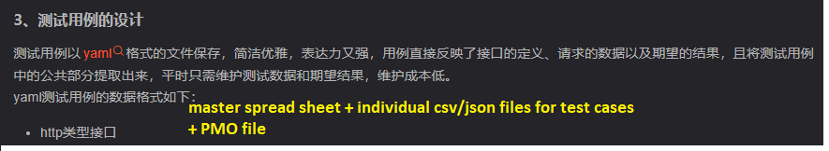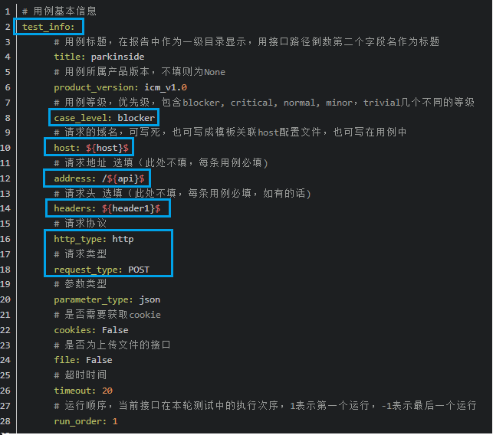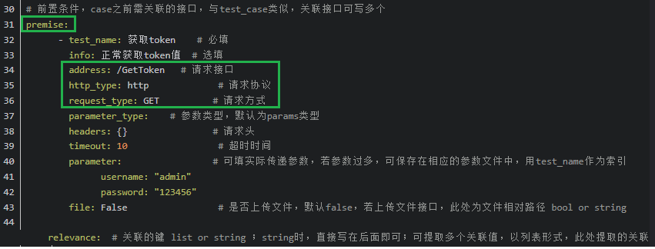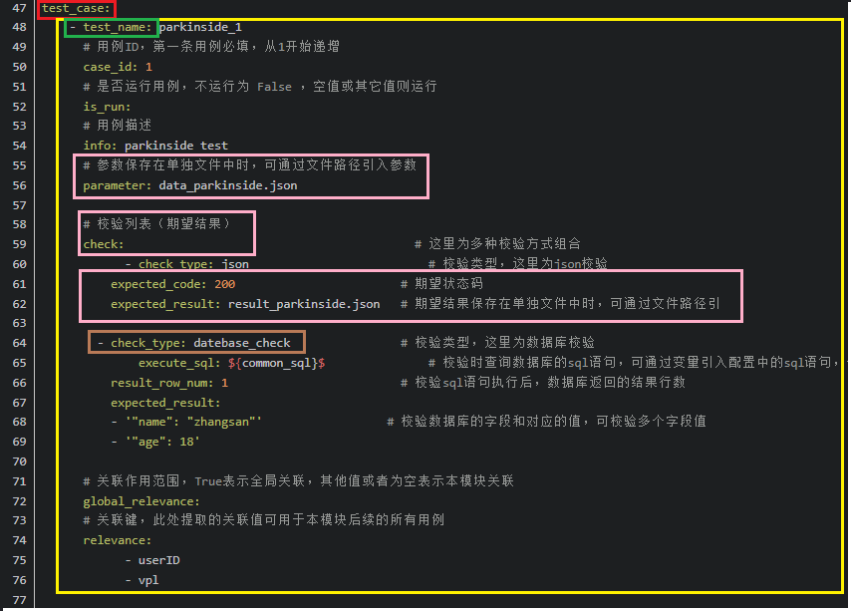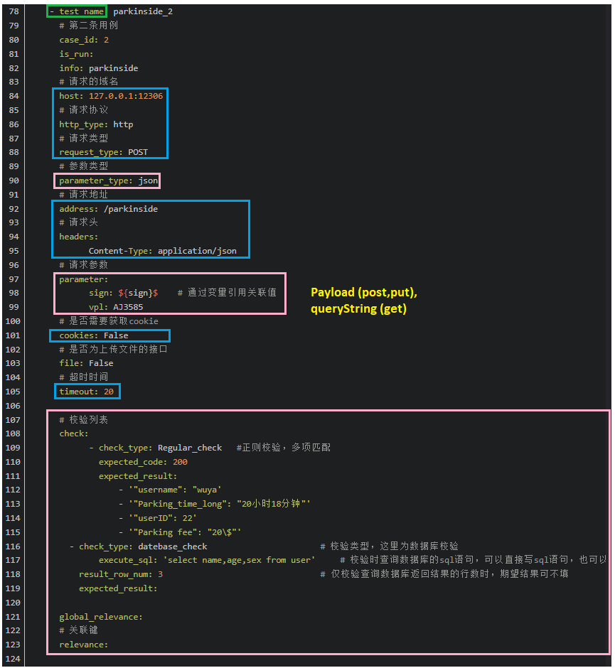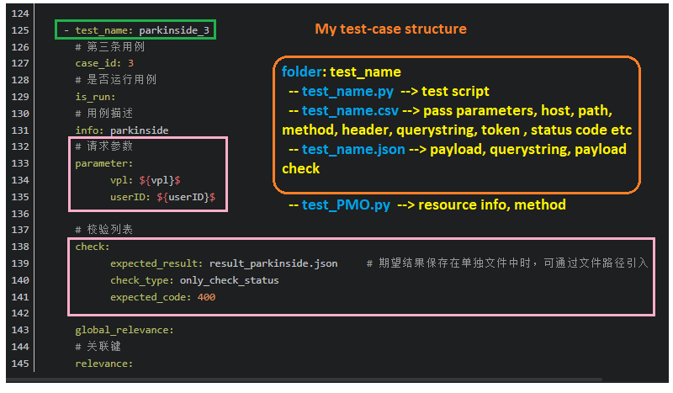 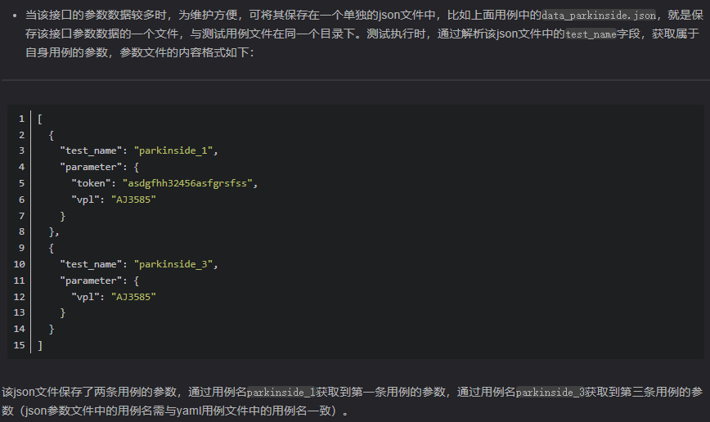 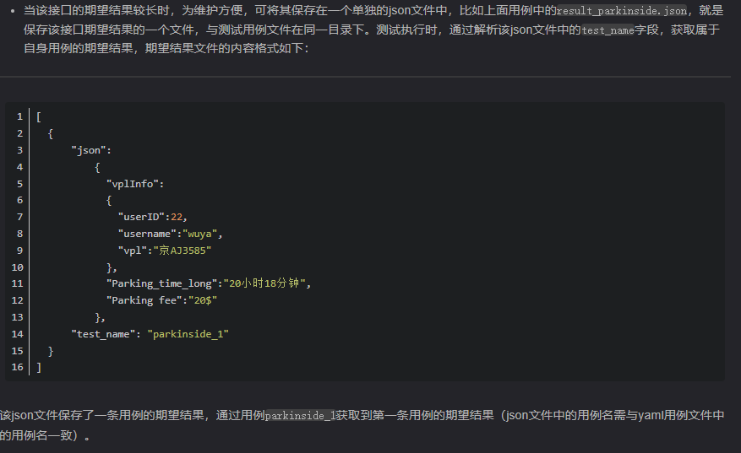 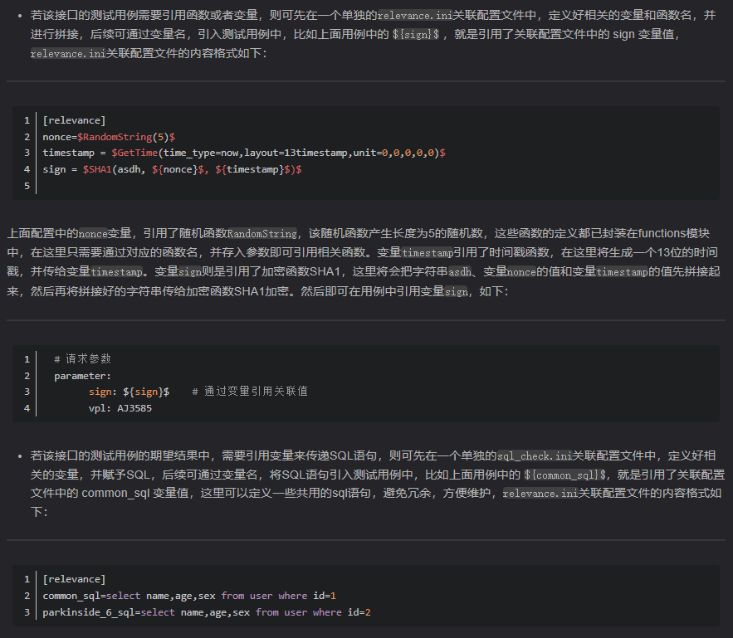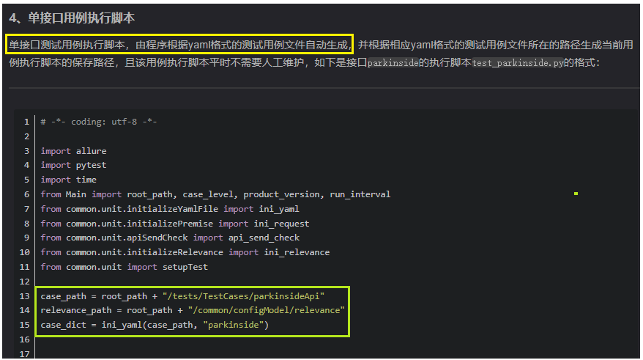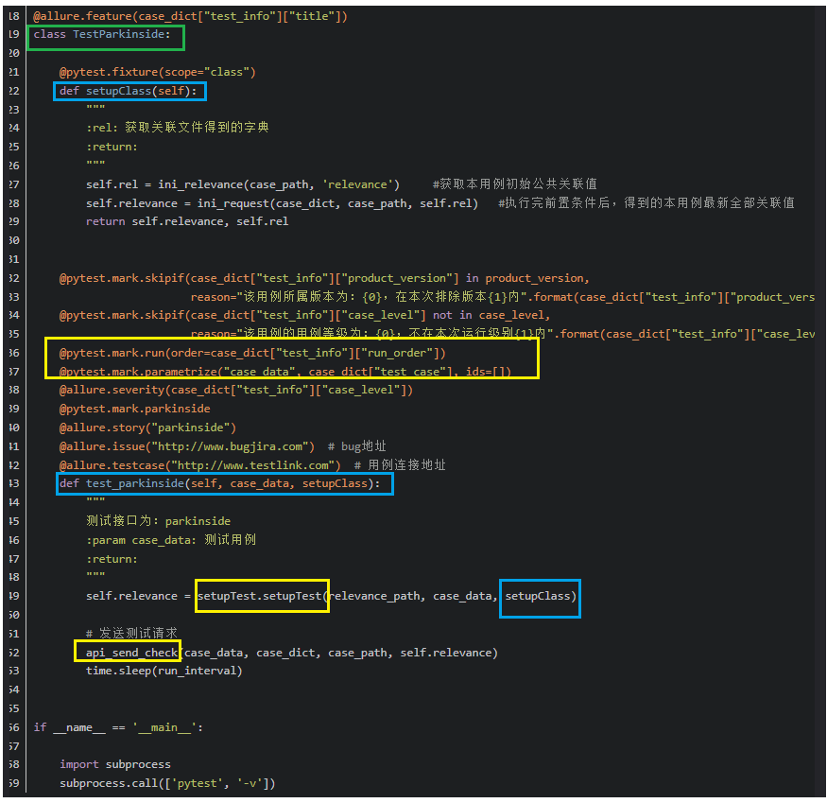 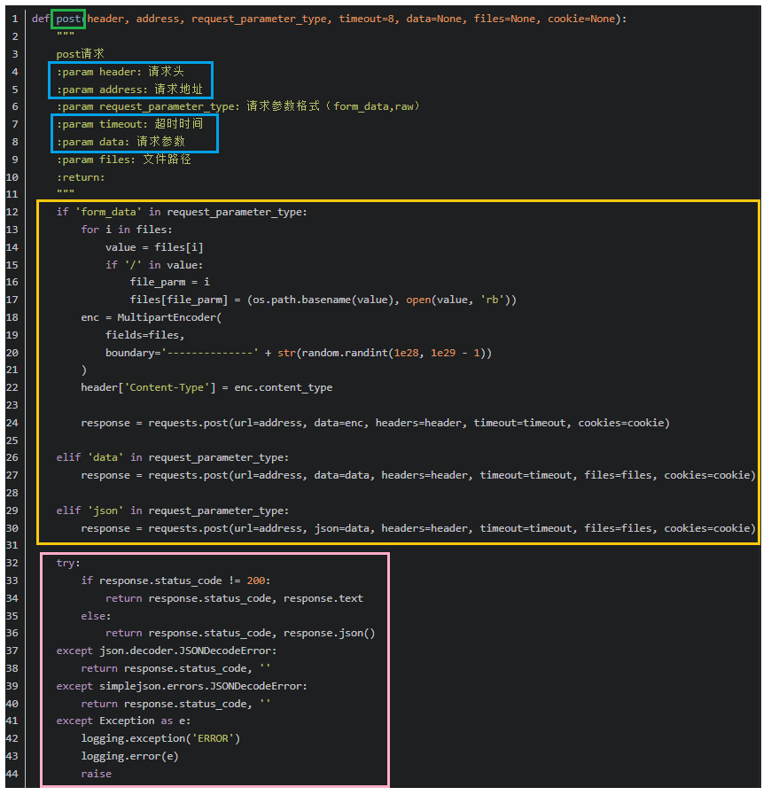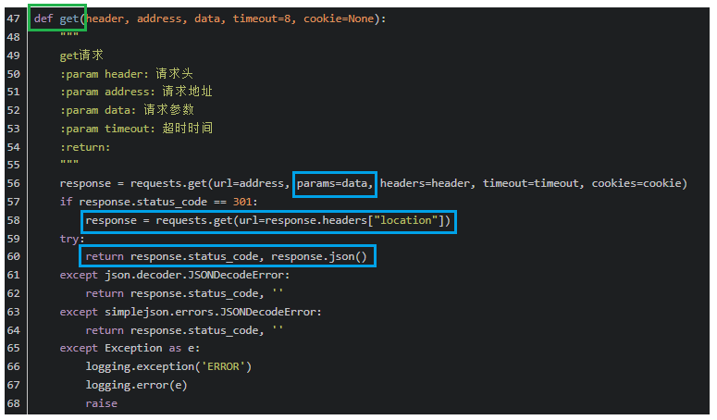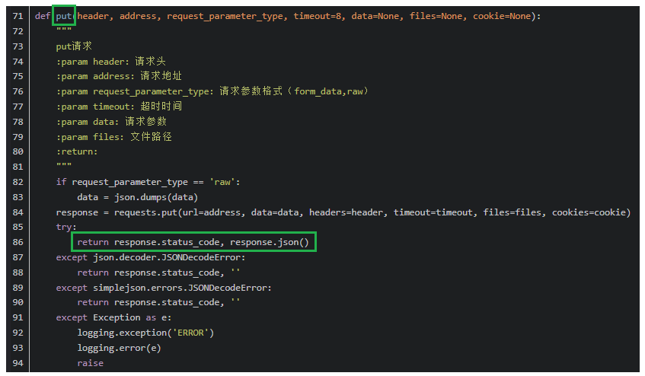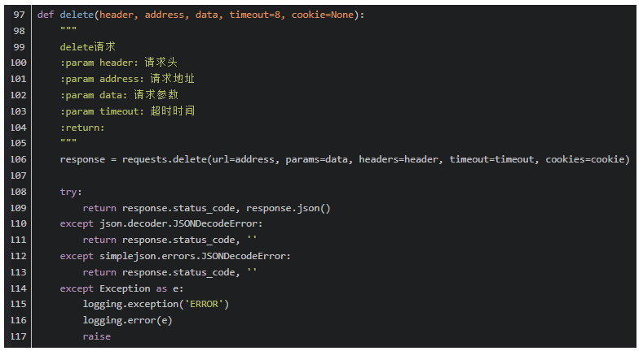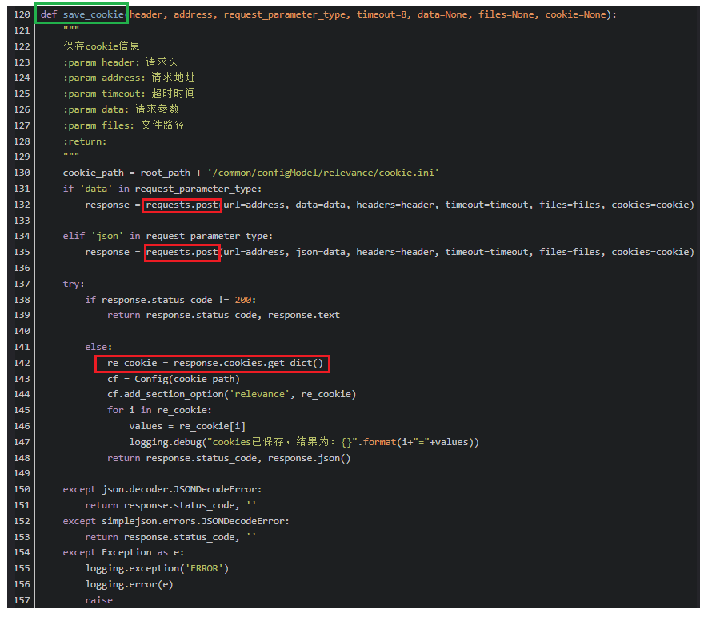  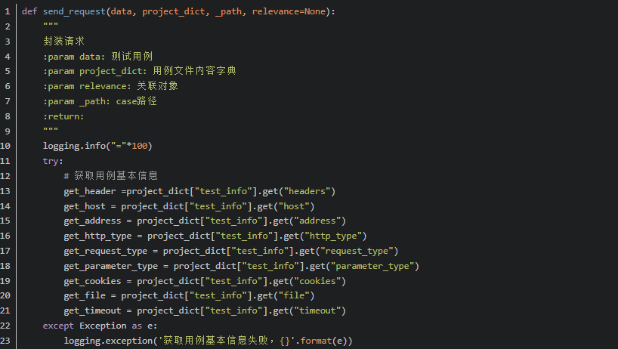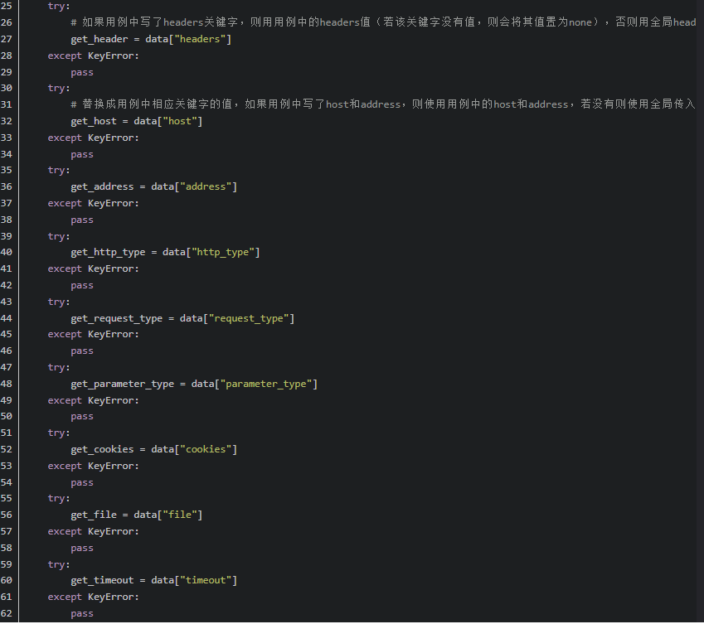 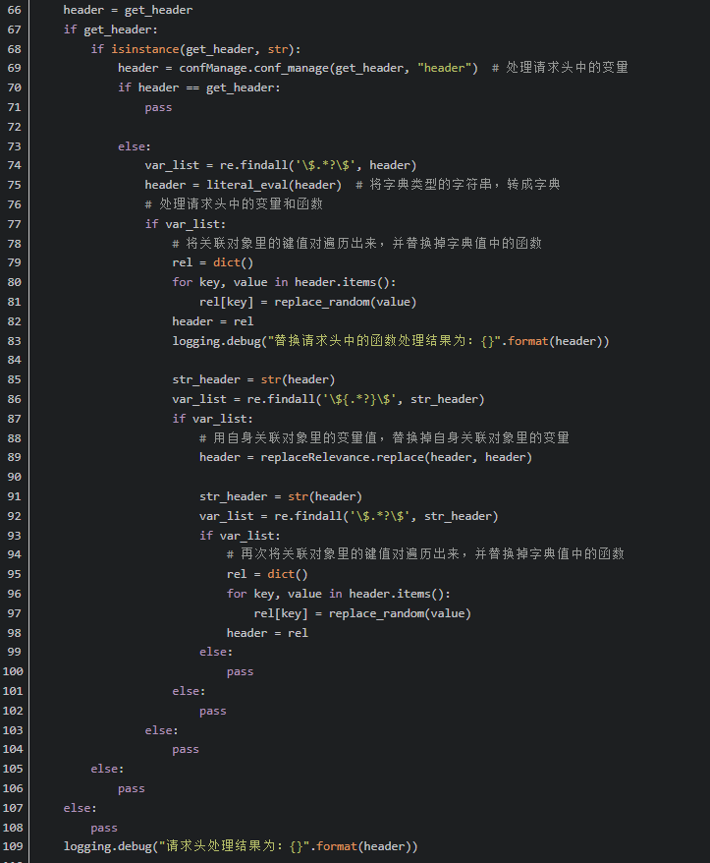 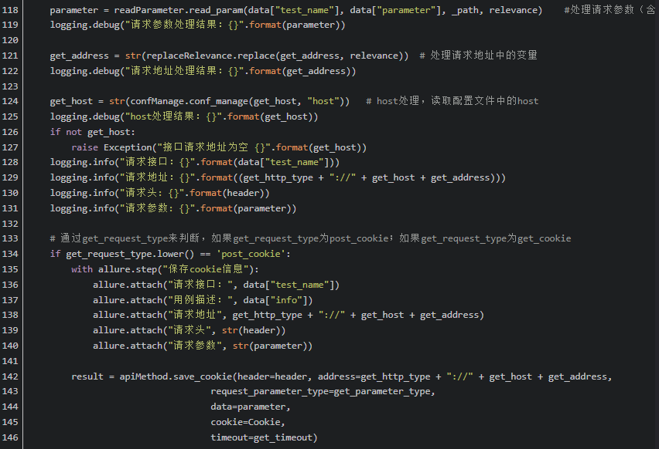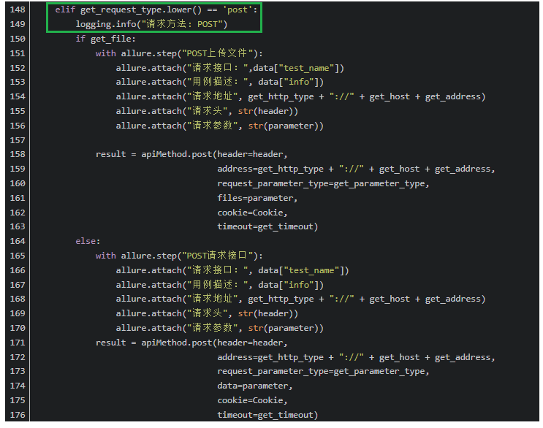 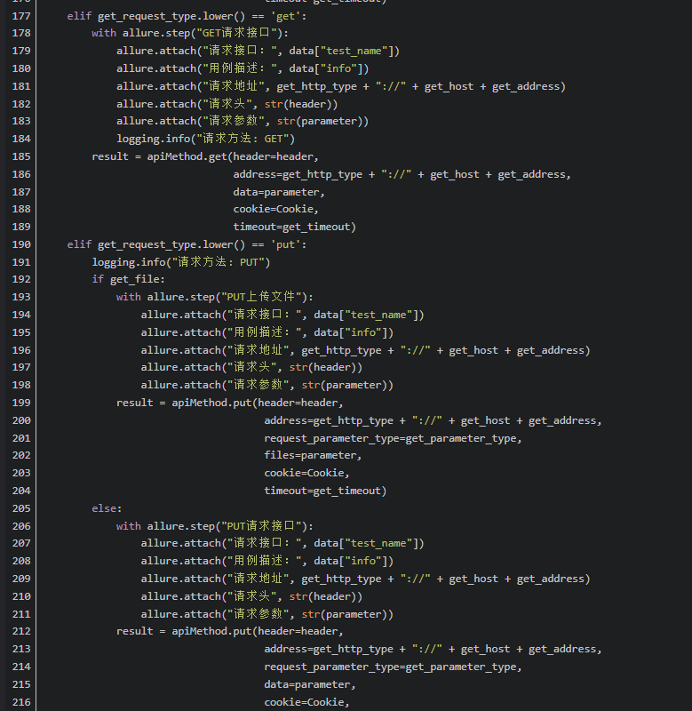 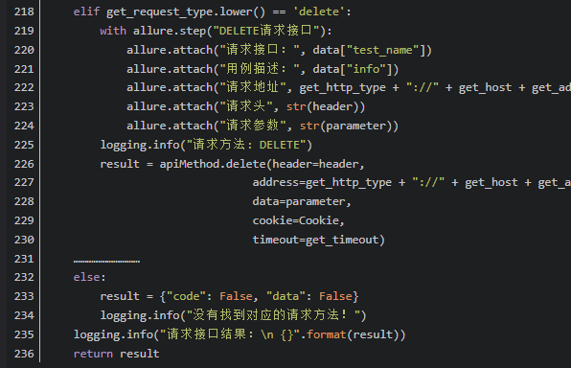 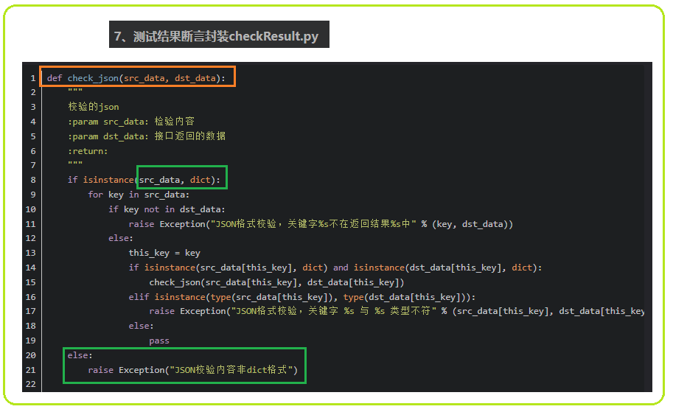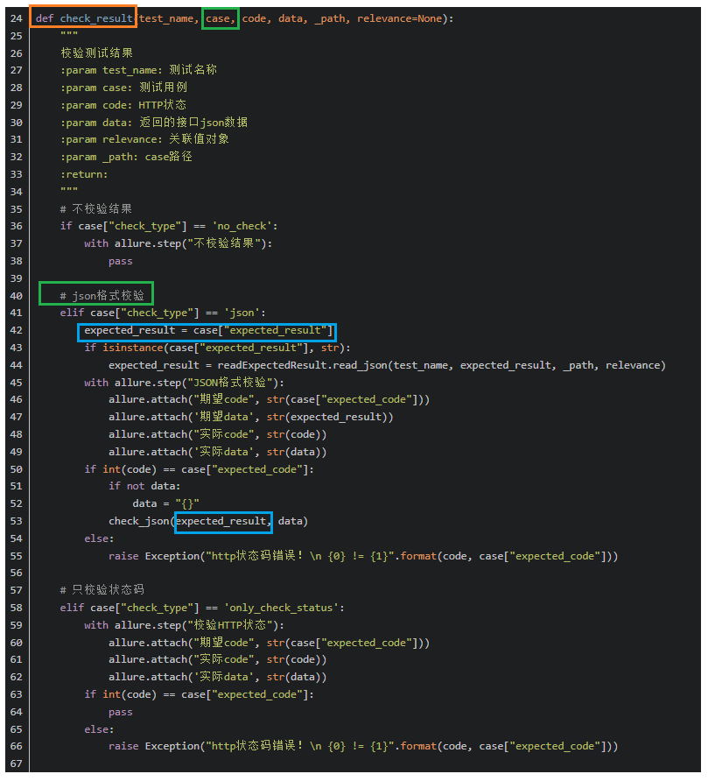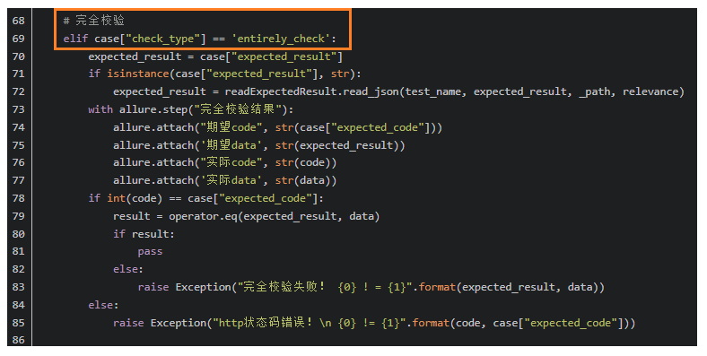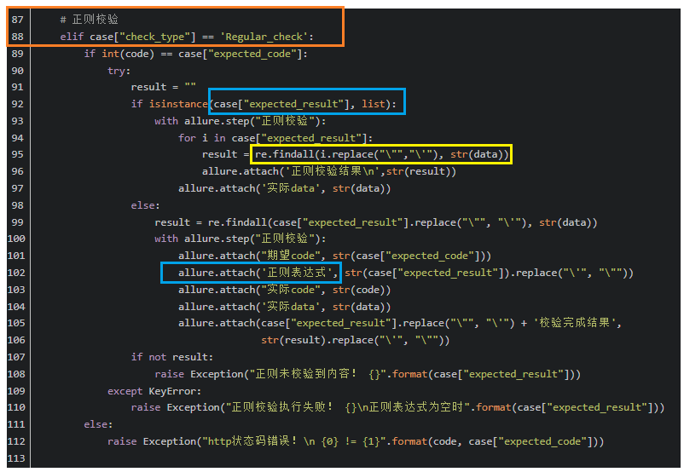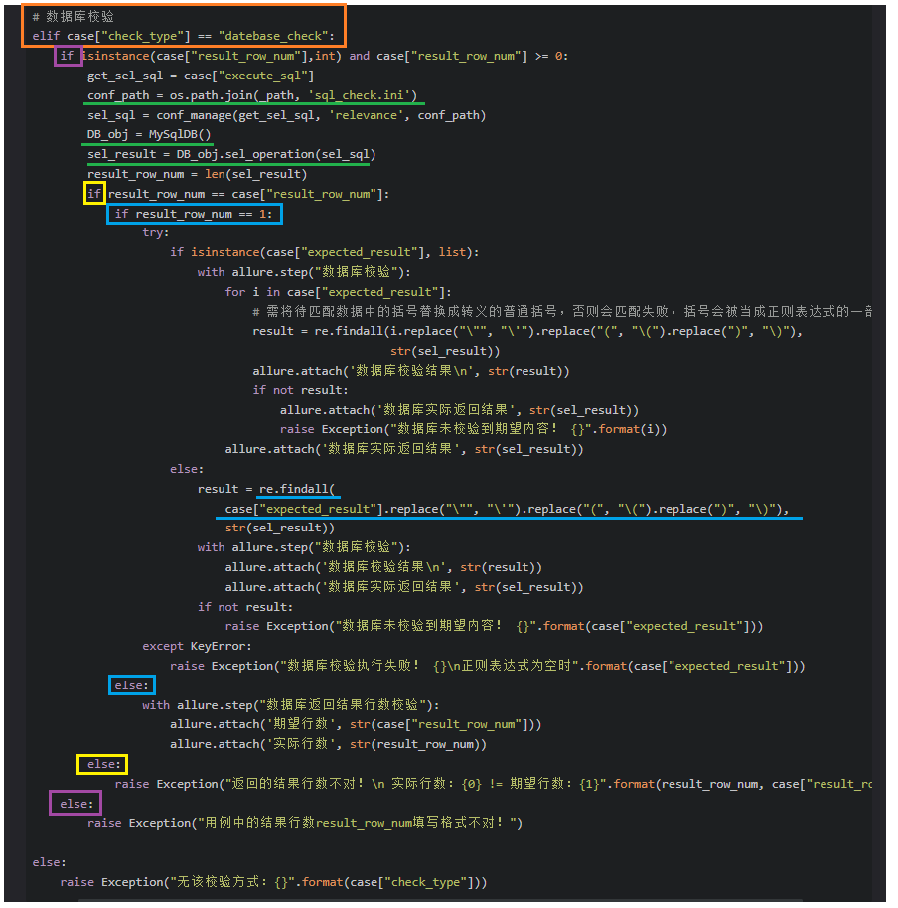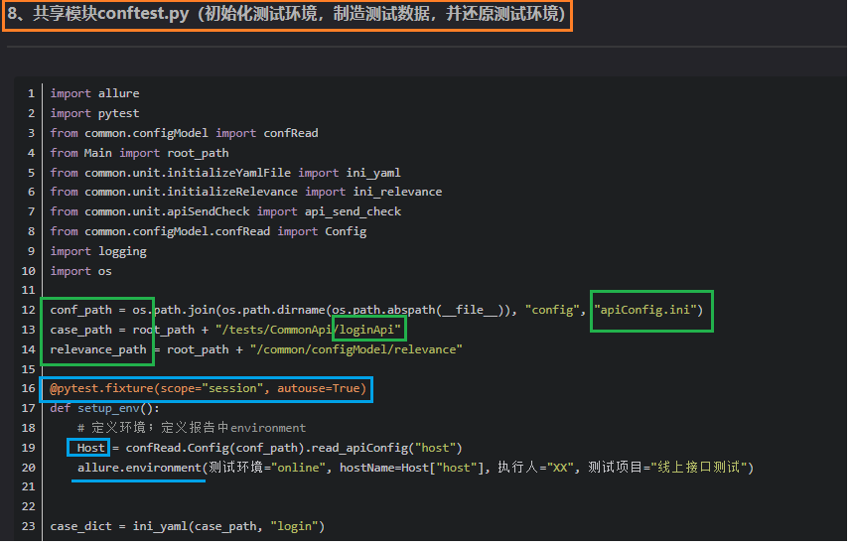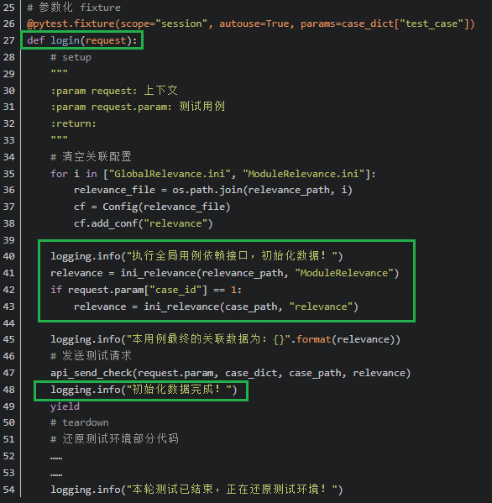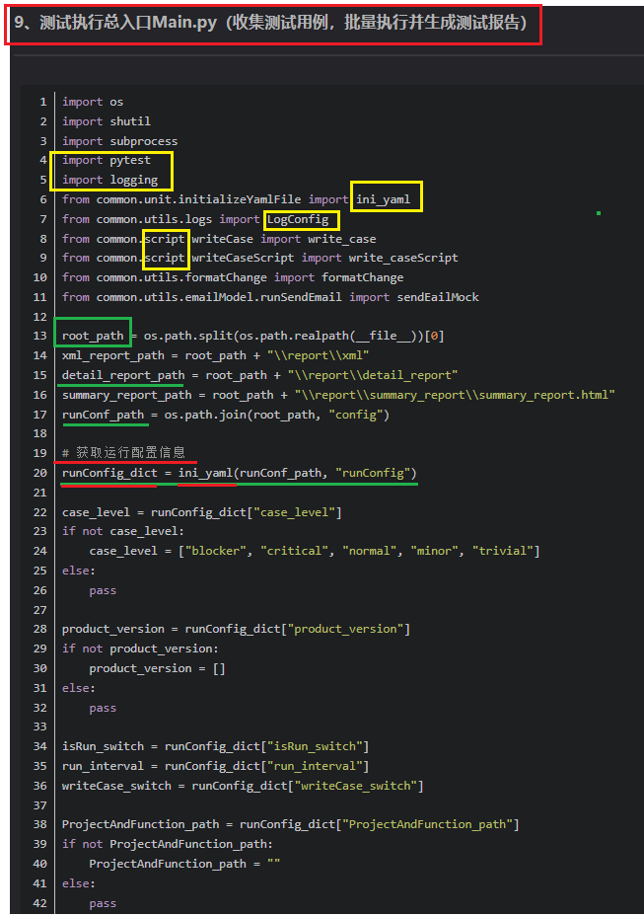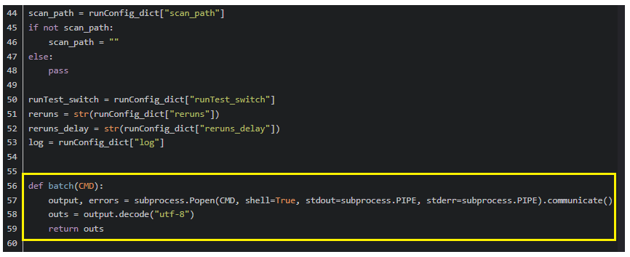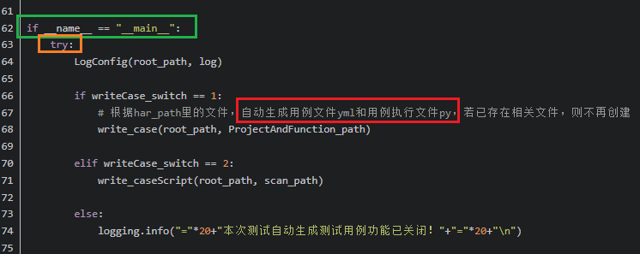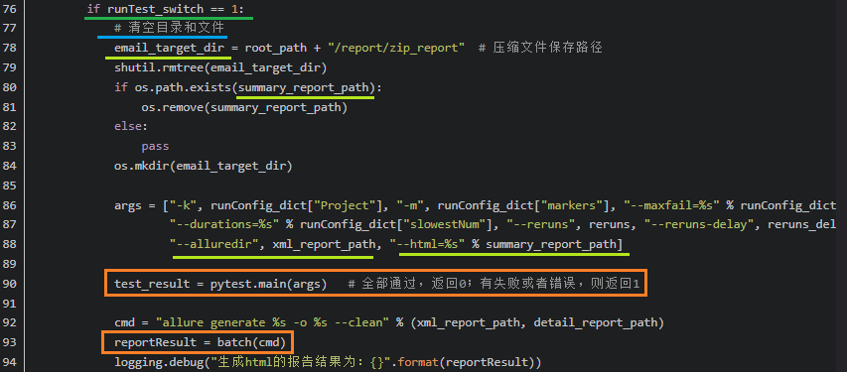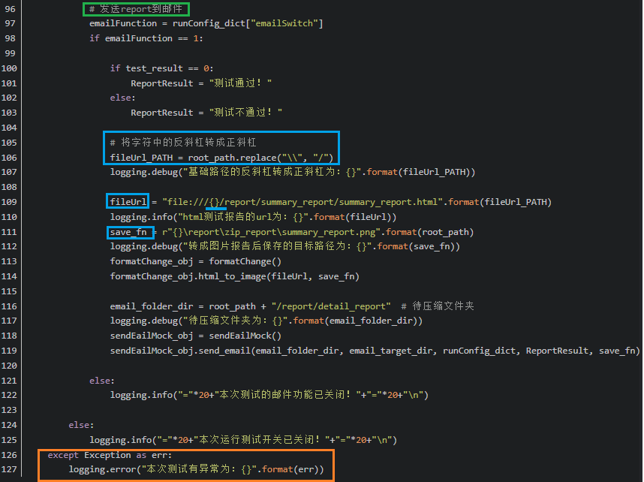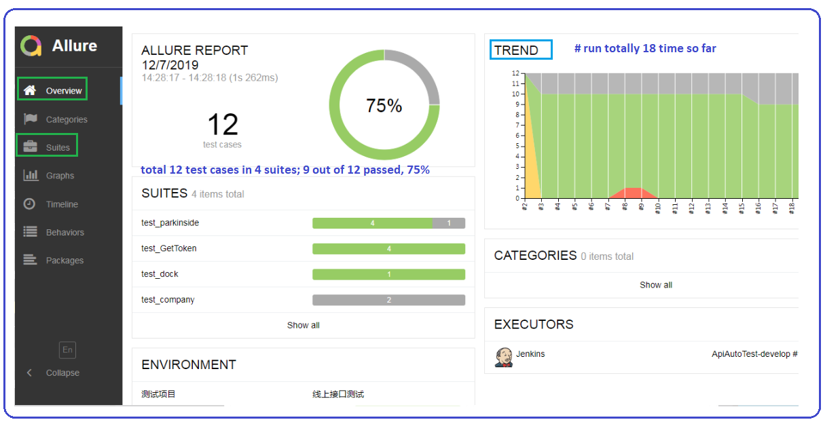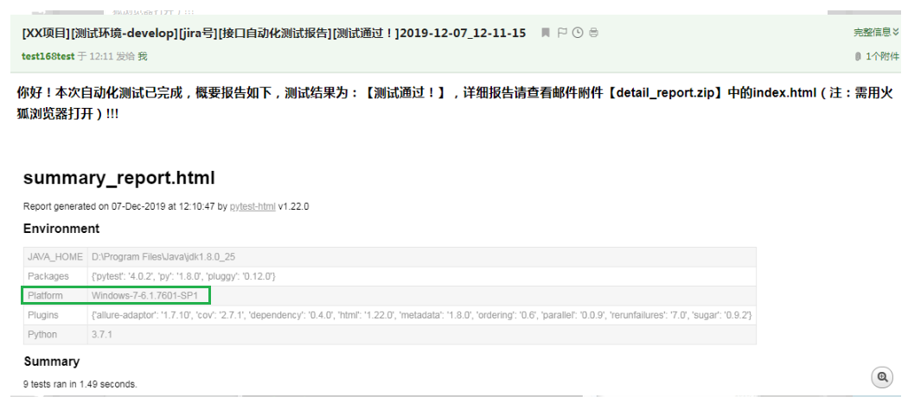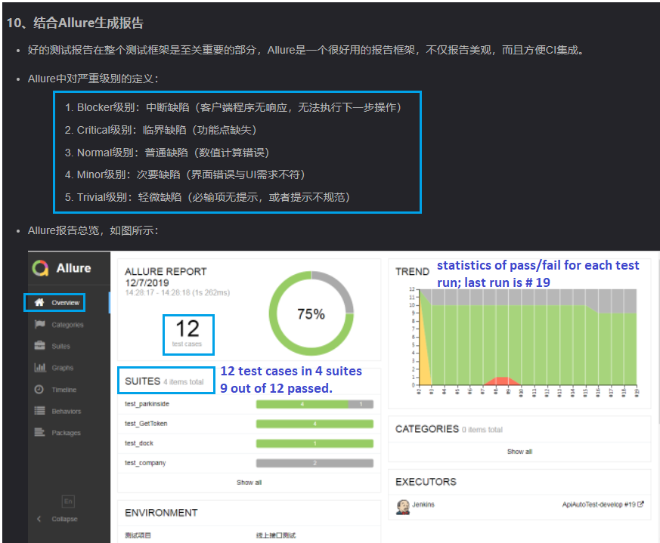

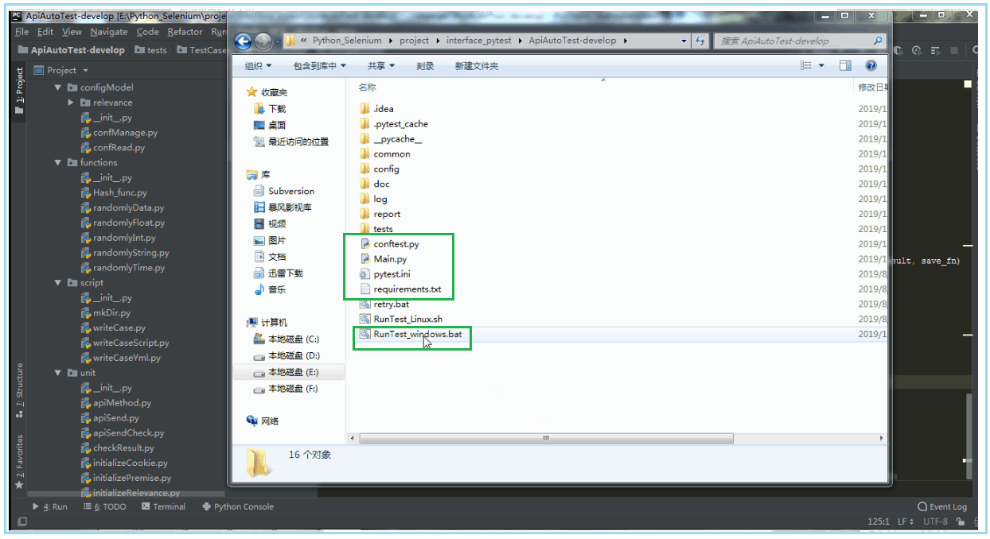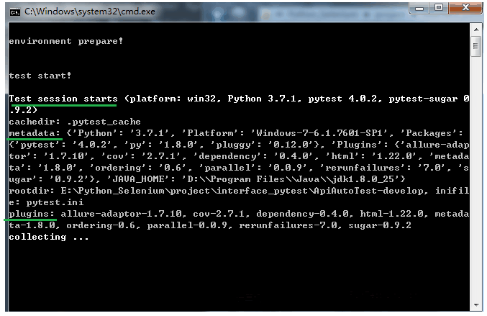

1. **Example 2**

